**Karnataka State Finance Corporation Project Setup**

**Steps to clone the project**

1. **Step 1:**

* Login to Bitbucket **–** [**bitbucket.org**](https://bitbucket.org/product/)
* Credentials for Bitbucket**:**

User: dev_two@epicmindsit.com

Password: Welcome@2

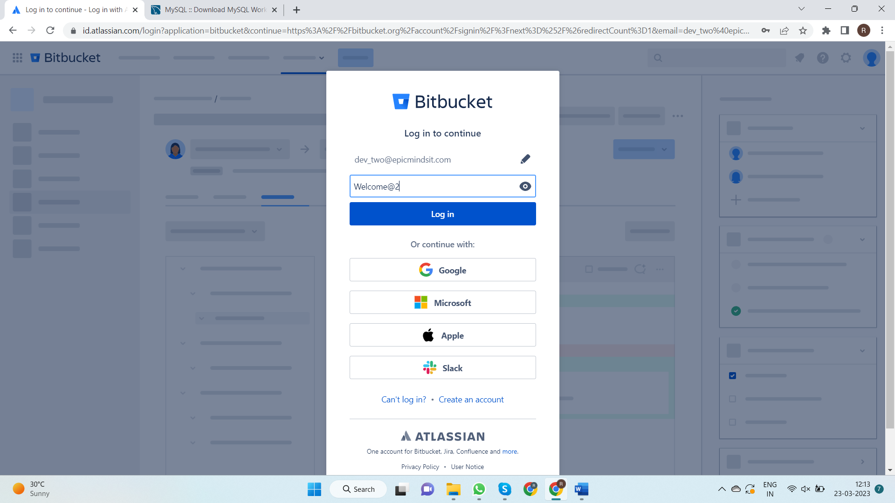

1. **Step 2:**

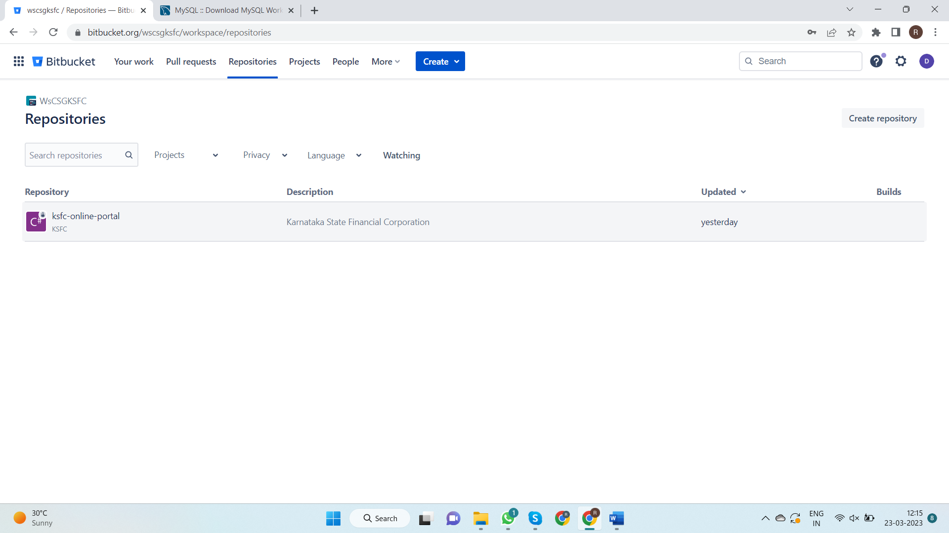

* Under Repositories section click on Repository named **“KSFC-Online Portal”.** The following screen appears**.**

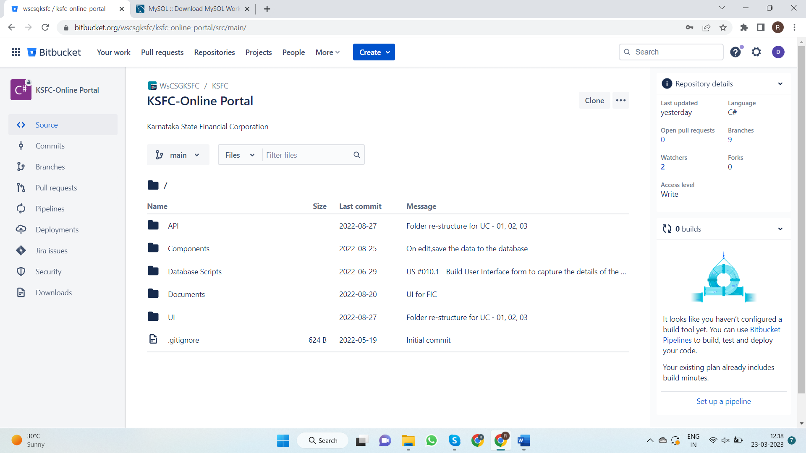

* In the above screen click on clone Button which is on top right corner of the screen**.**

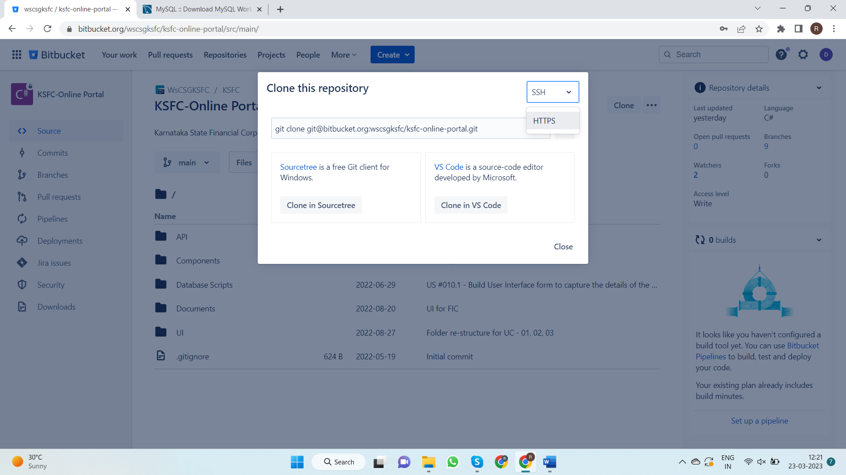

* Change the protocol from **“SSH”** to **“HTTPS”**
* Copy cloning link**.**

1. **Step 3:**

* Open visual studio and click on **“Clone a repository”**

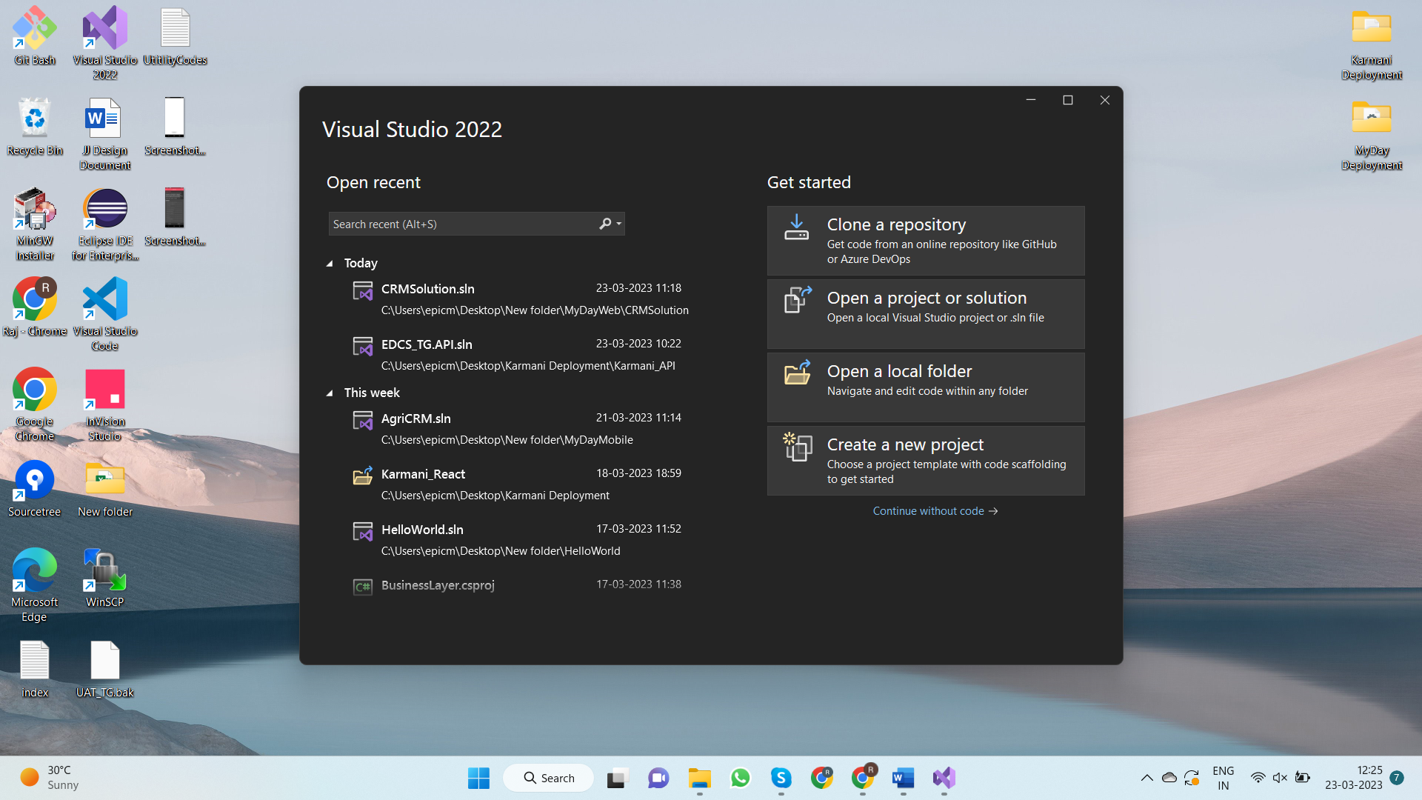

* Paste the link for cloning the project in Repository location field
* Create a folder named **“KSFC”** under **“D”** drive and browse the path to that folder and click on clone

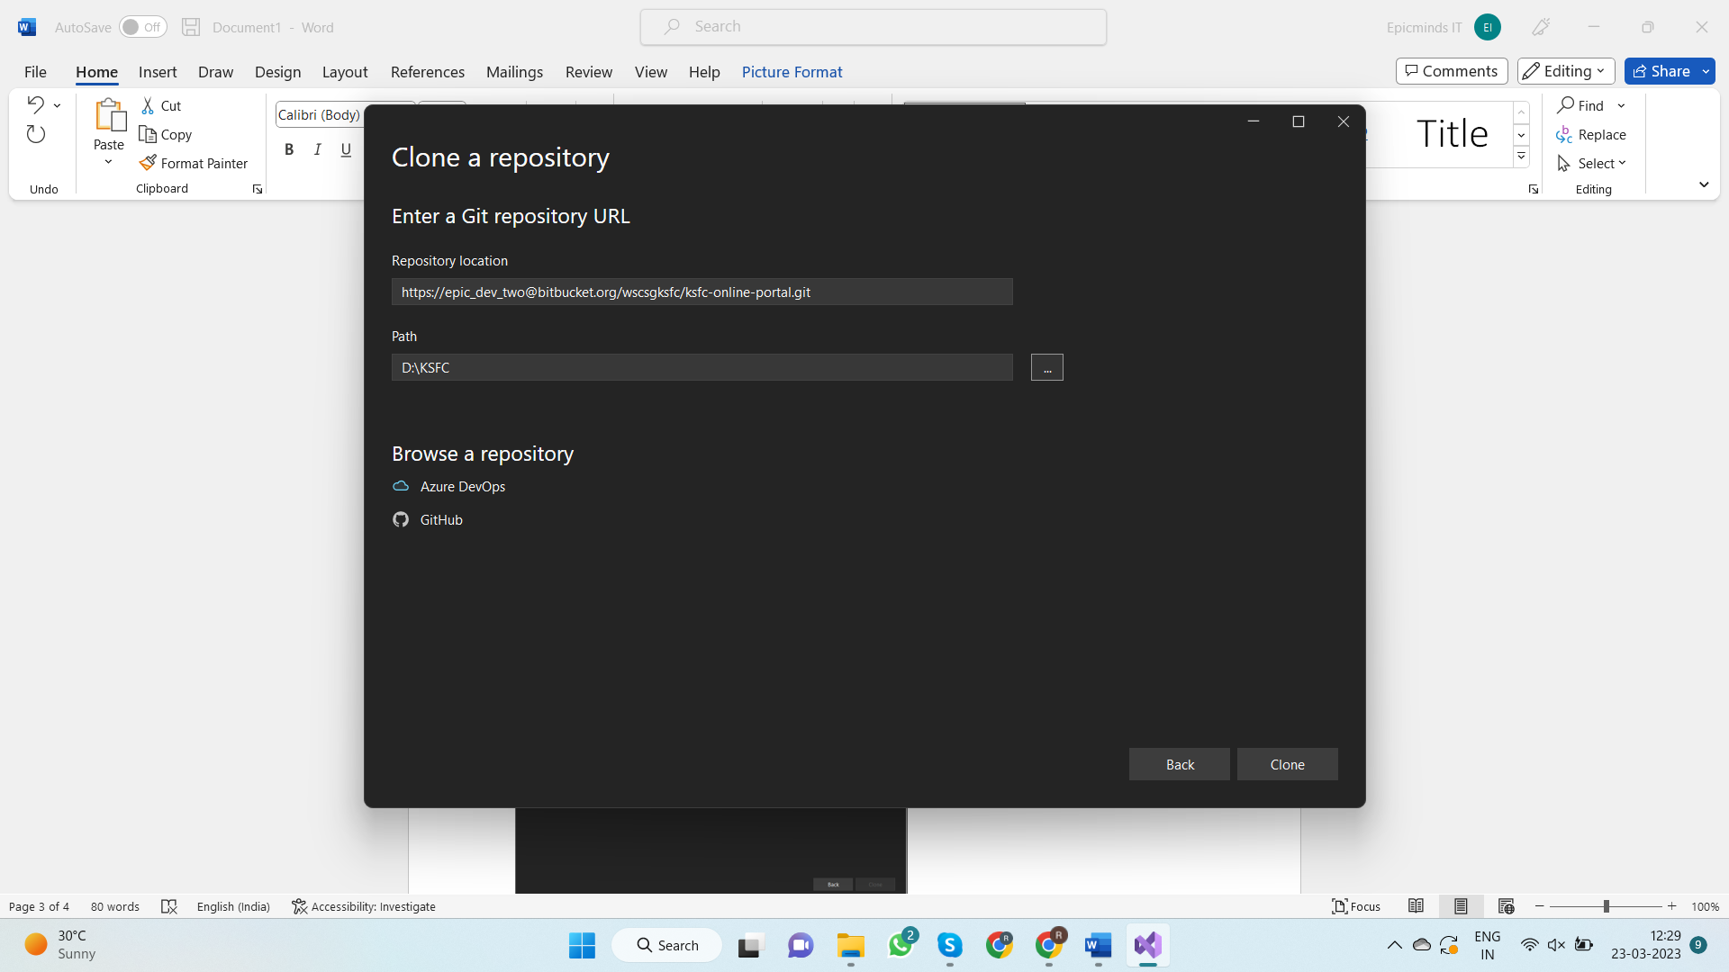

* Once the project has been cloned change the branch to **“origin/feature/IDM_Module”**

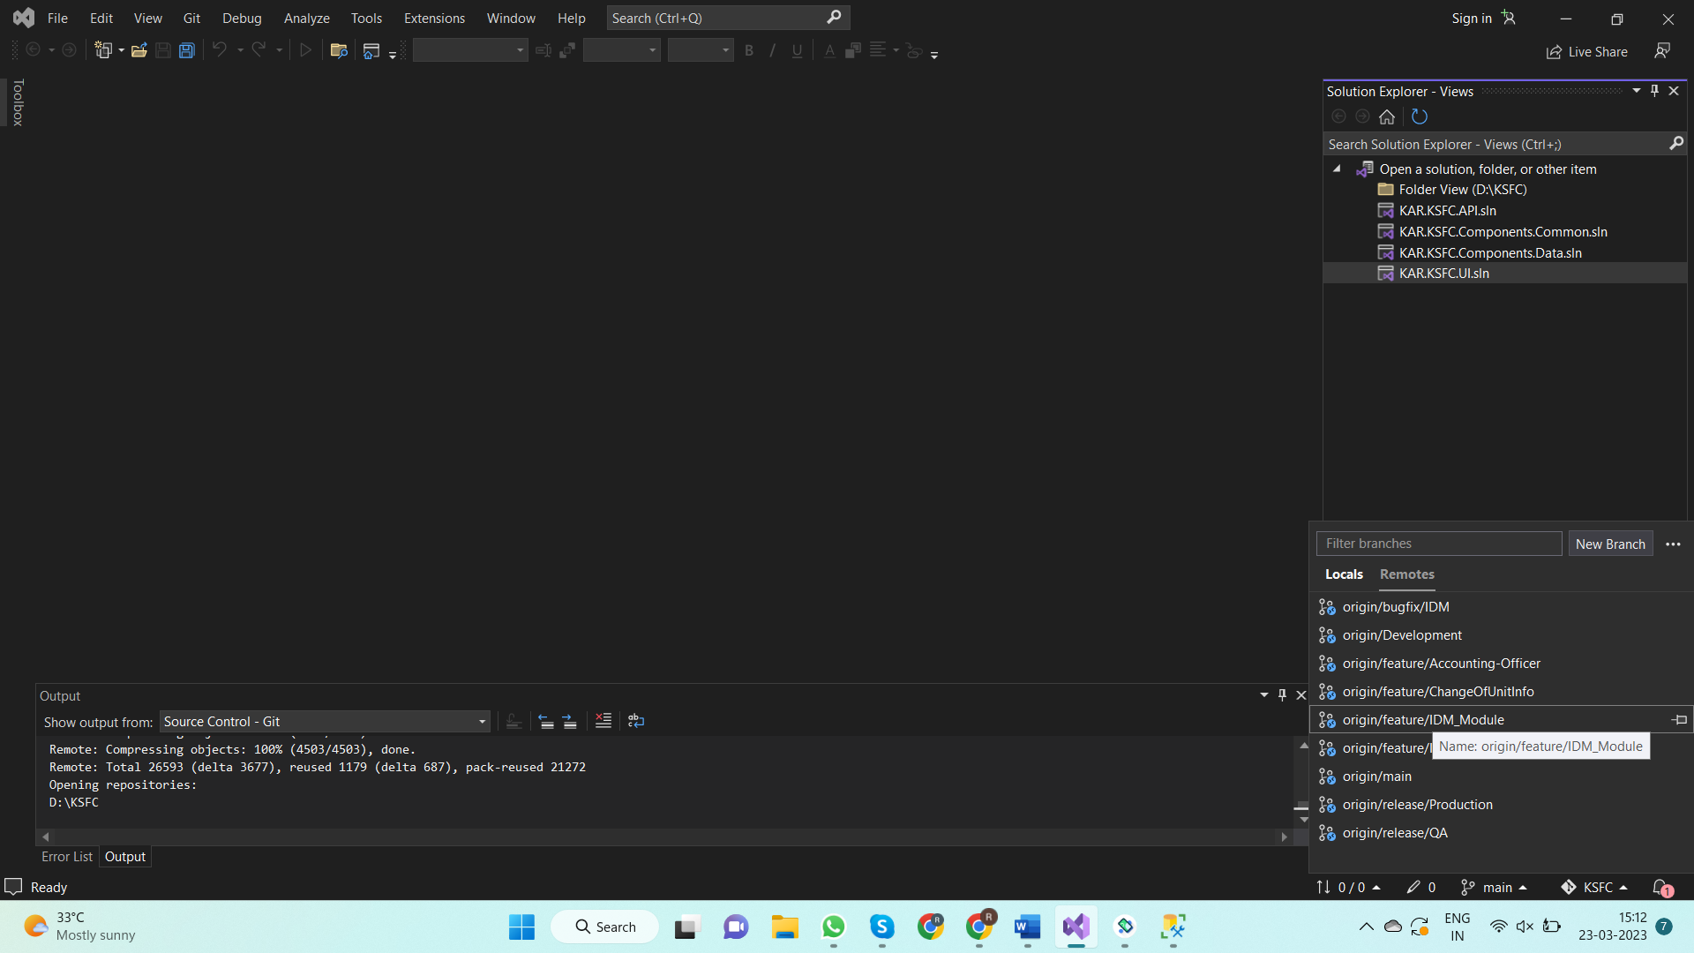

**Steps to setup MySQL**

**1.Step 1:**

* Go to following link and download latest version of MySQL

**URL -** [**https://dev.mysql.com/downloads/workbench/**](https://dev.mysql.com/downloads/workbench/)

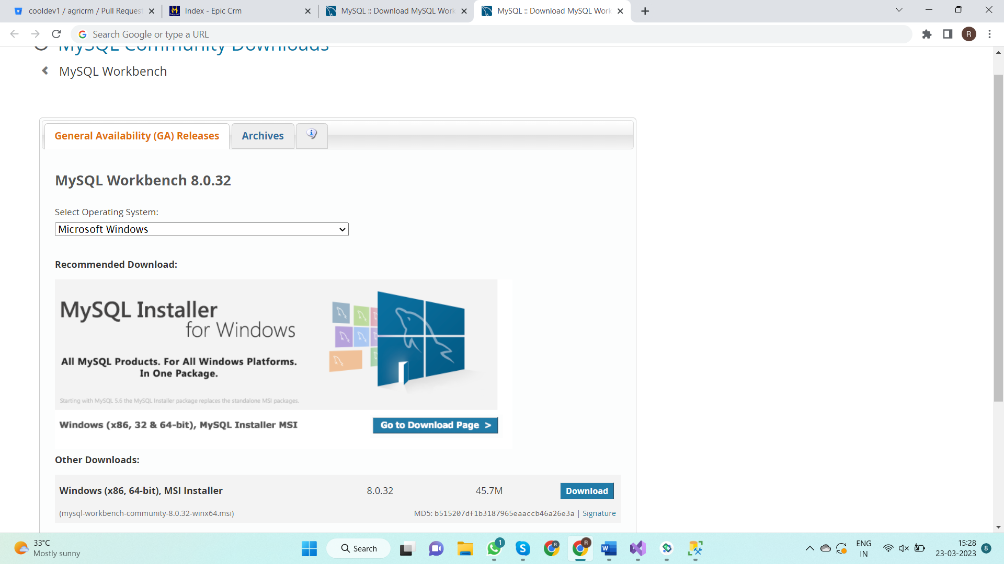

**2.Step 2:**

* Once the download is completed, locate the file in downloads and double click on file. The following popup opens. Click on next.

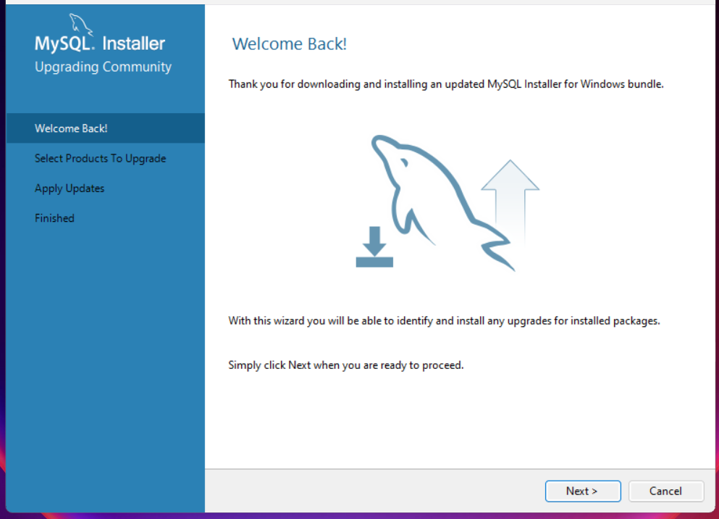

* Choose the setup type as **“Developer Default”** and click next

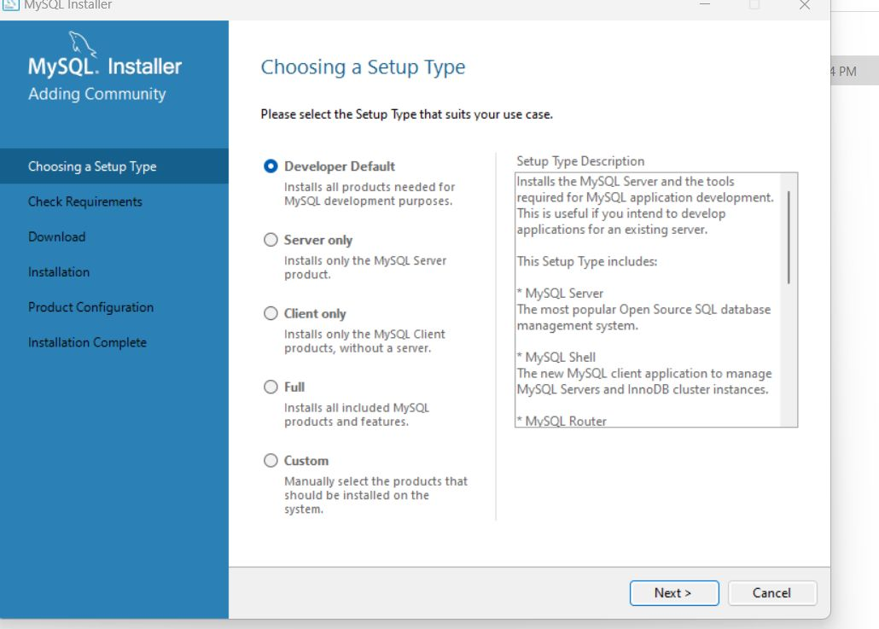

* In the next step the required product for MySQL will be installed

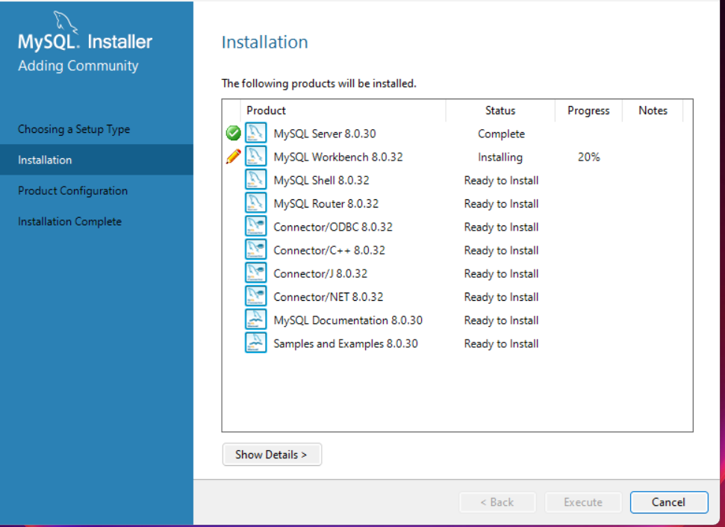

* Then **“Type and Networking”** screen will appear. Click on next

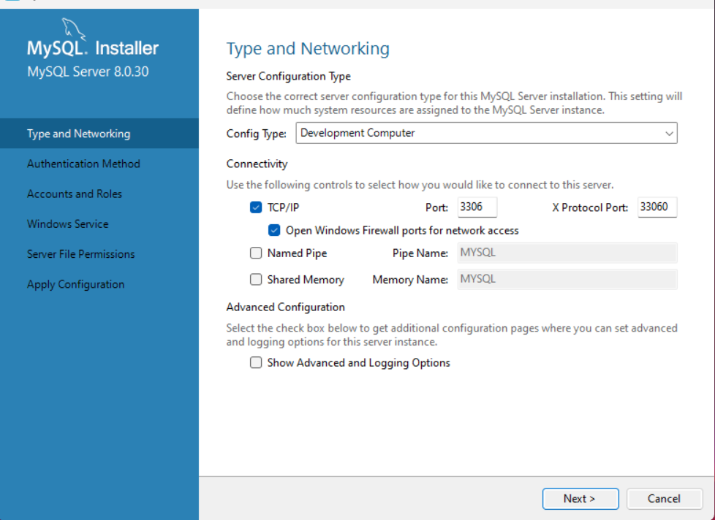

* In the **“Authentication Method”** select **“Use strong Password Encryption for Authentication”** and click on next

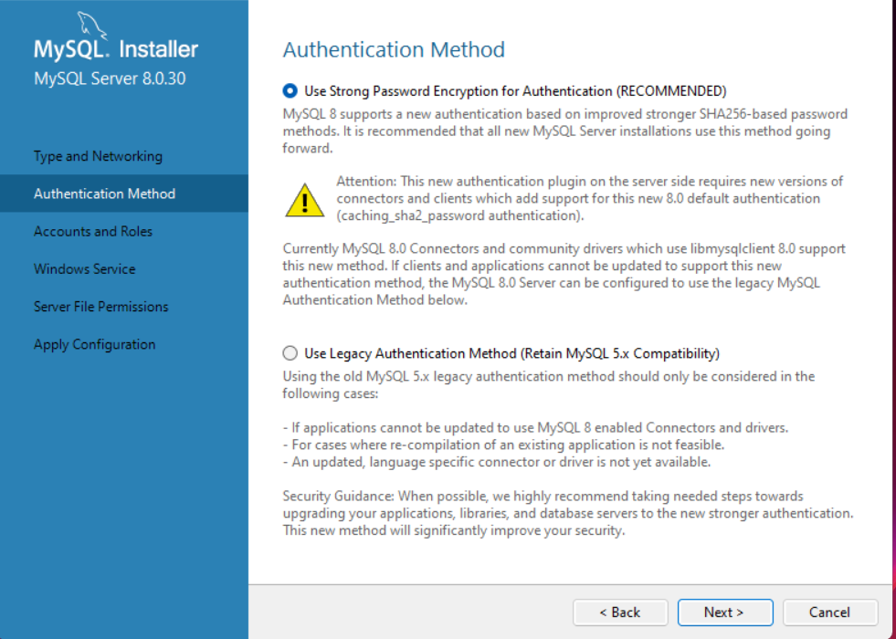

* In **“Accounts and Roles”** Screen create your own password in **“Root Password”** and **“Repeat Password”** field and click on next

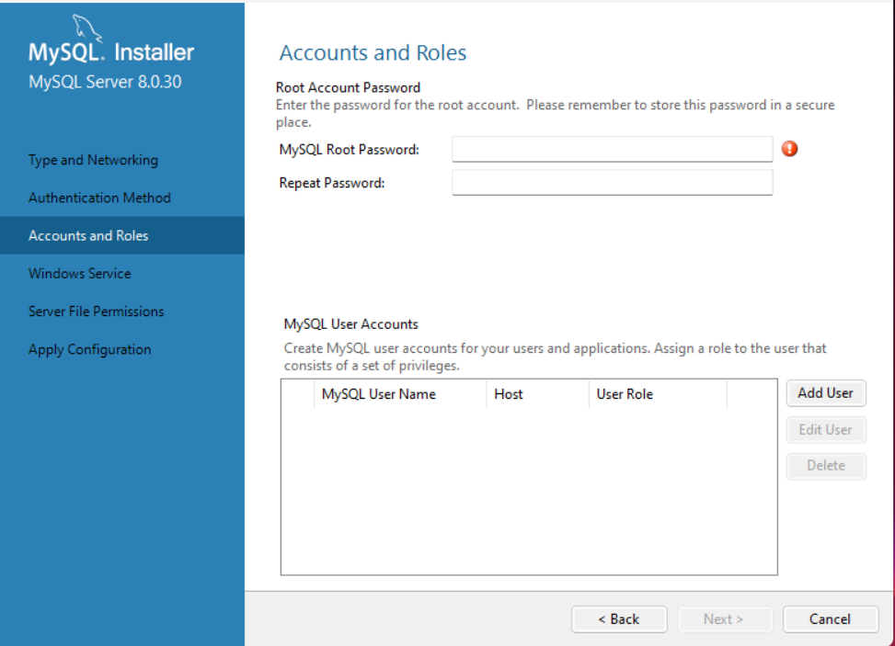

* **“Windows Service”** screen appears.Click on next.

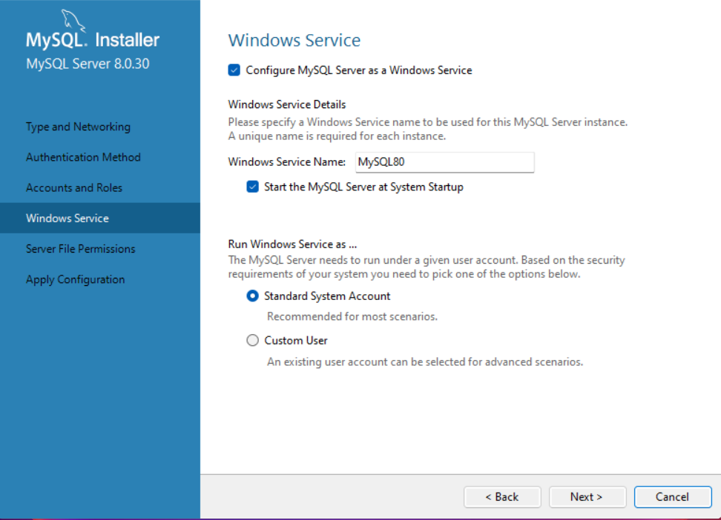

* **“Server File Permissions”** screen appears.Click on next.

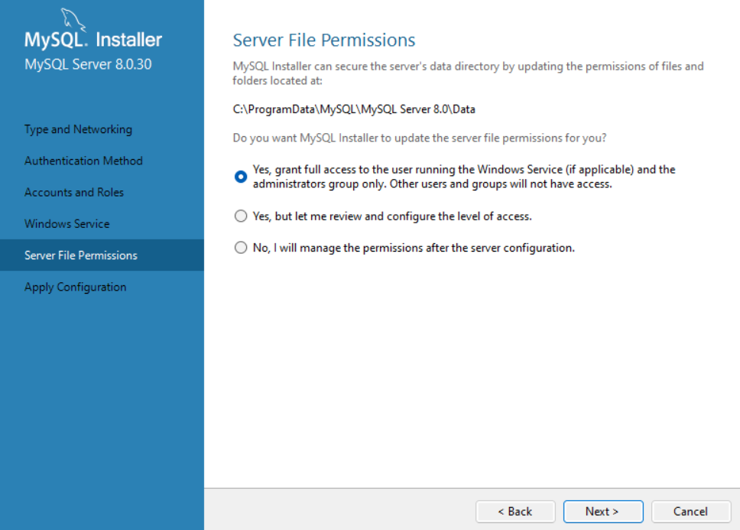

* **“Apply Configuration”** Screen appears**.** Click on execute

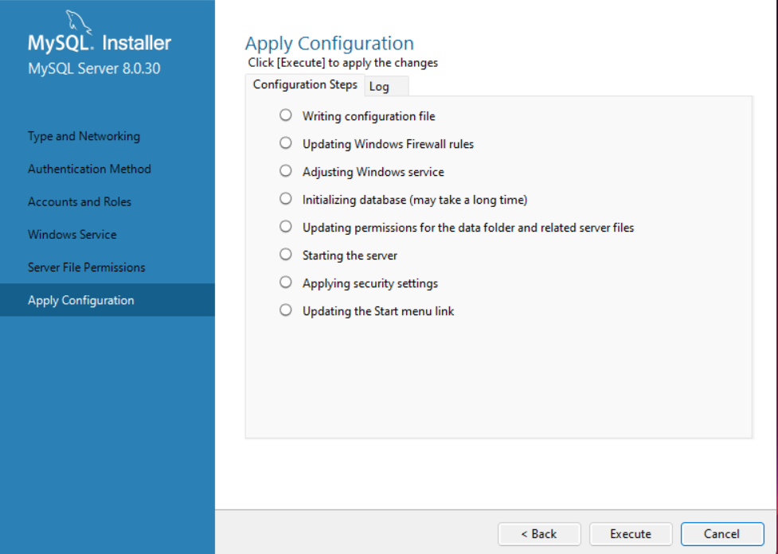

* **“Product Configuration”** Screen appears**.** Click on next

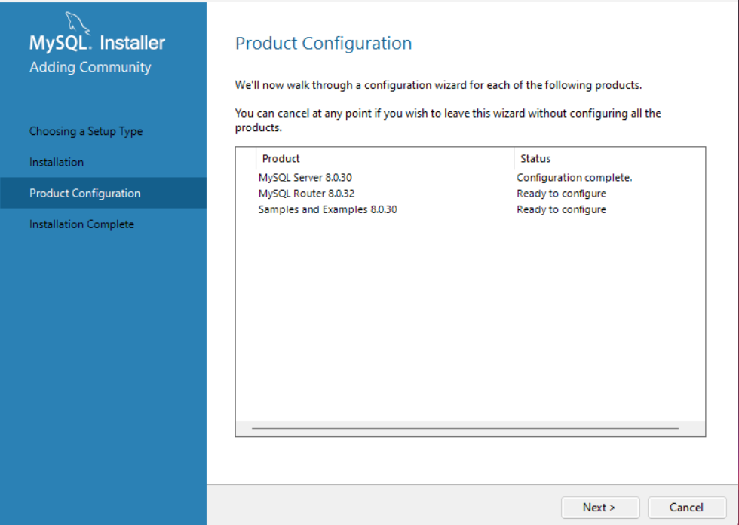

* **“MySQL Router Configuration”** Screen appears. Click on Finish.

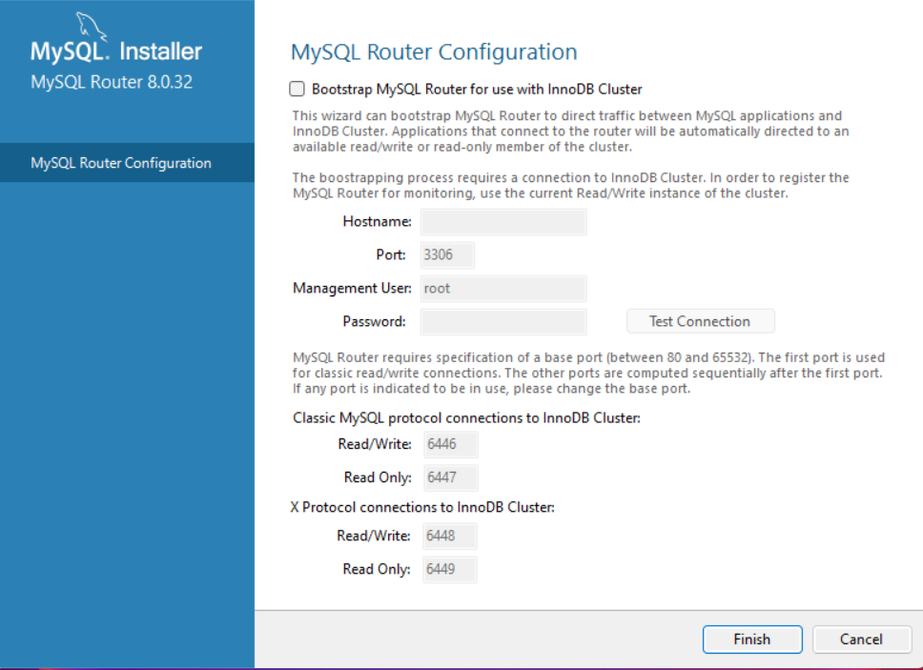

* In **“Connect to Server”** Screen Enter the password you created in the password field and click on next.

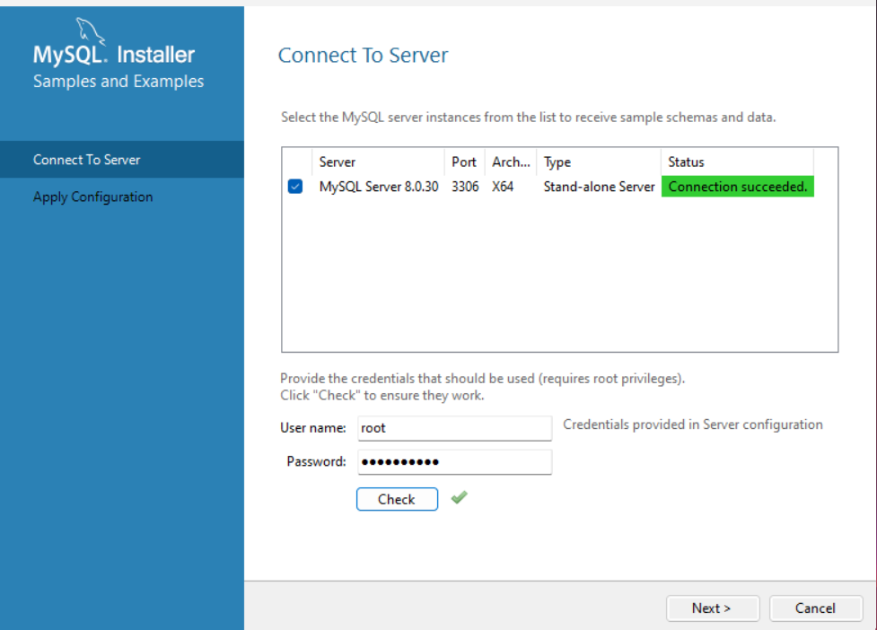

* Then we will get the **“Installation Completed”** Screen.Click on finish

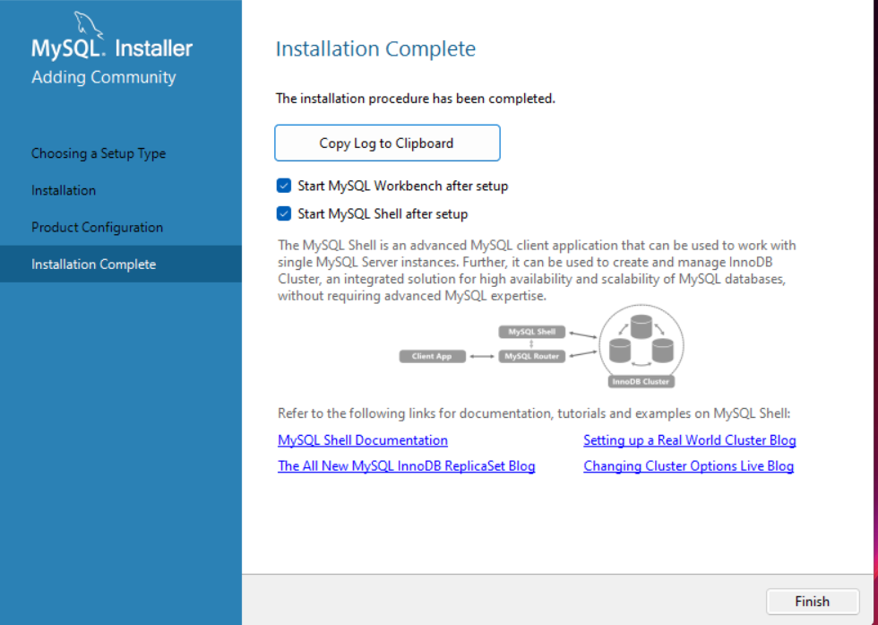

**Steps to Import Existing Database Backup.**

**1.Step 1:**

* Open MySQL work bench. Click on (+) icon next to “**MySQL Connection”**

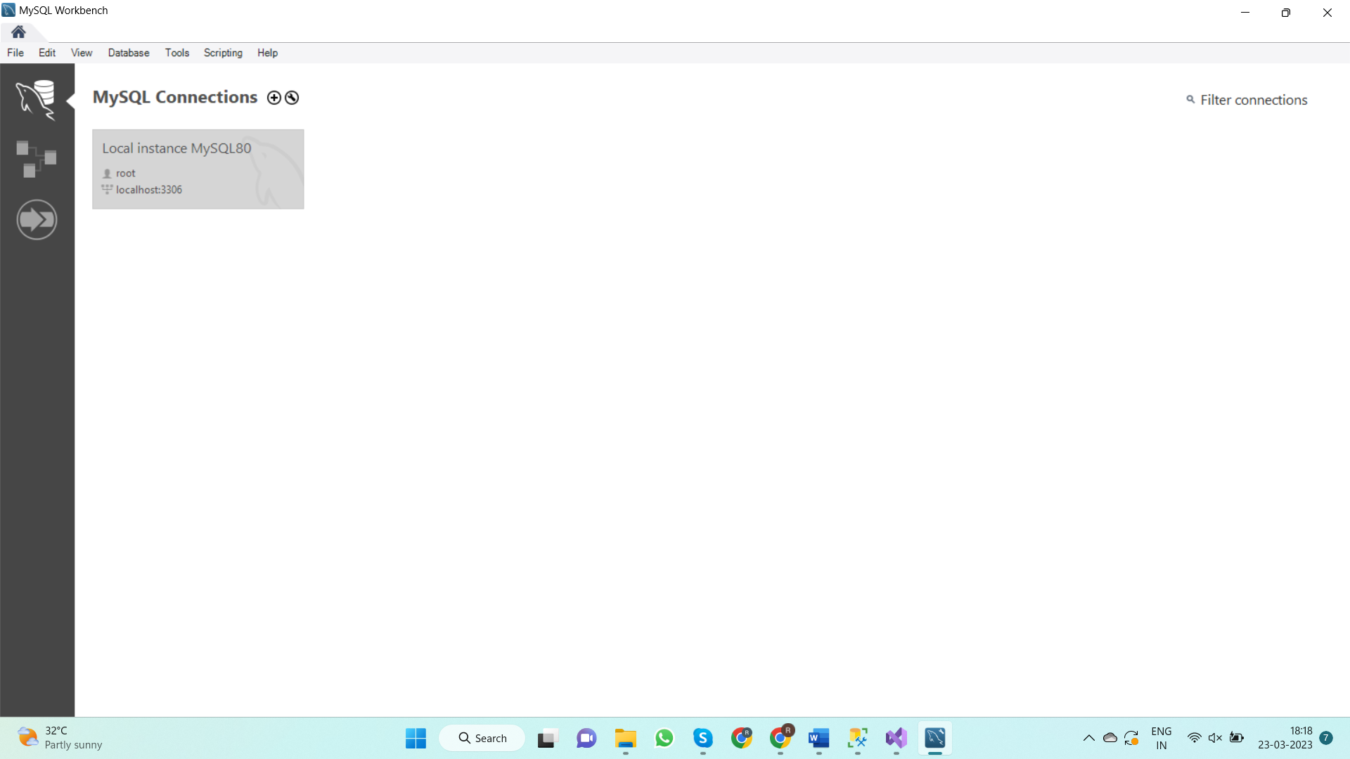

* When the following screen appears, Enter **“Connection name”** and Click on “**Store in Vault”** button next to Password field. New popup appears. Enter your password and “**click ok.”**

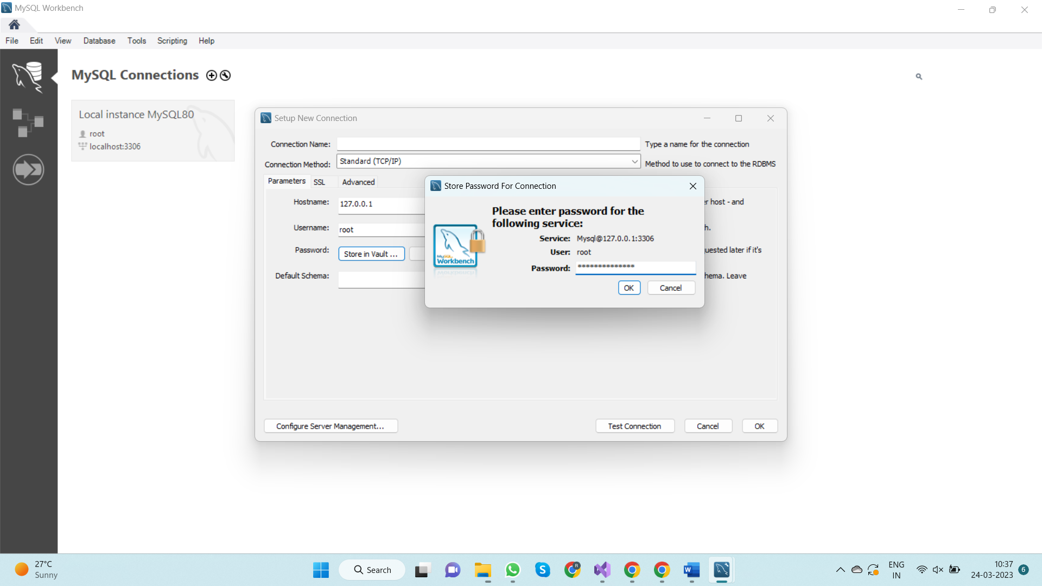

* **In the same screen click on Test Connection. The following Screen should appear.**

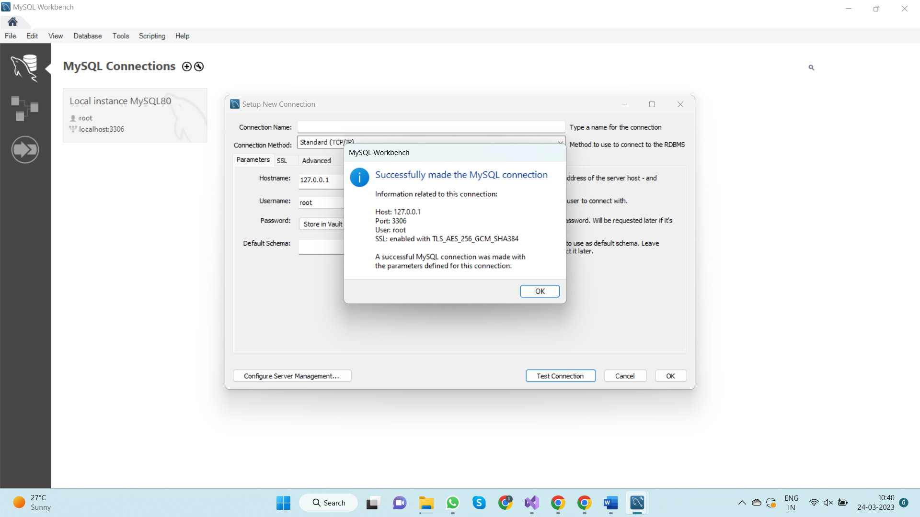

* Click Ok on both the screen and A New Card will appear below MySQL Connection Title. Click on the card to open new Instance on MySQL workbench.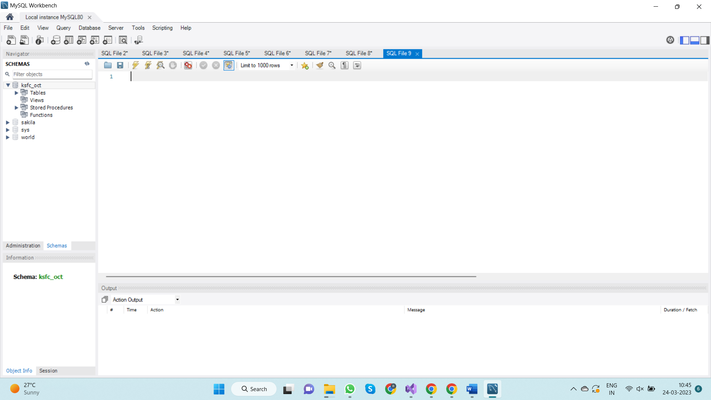

**2.Step 2:**

Click on **“Server”** in menu bar select “**Data Import”.**

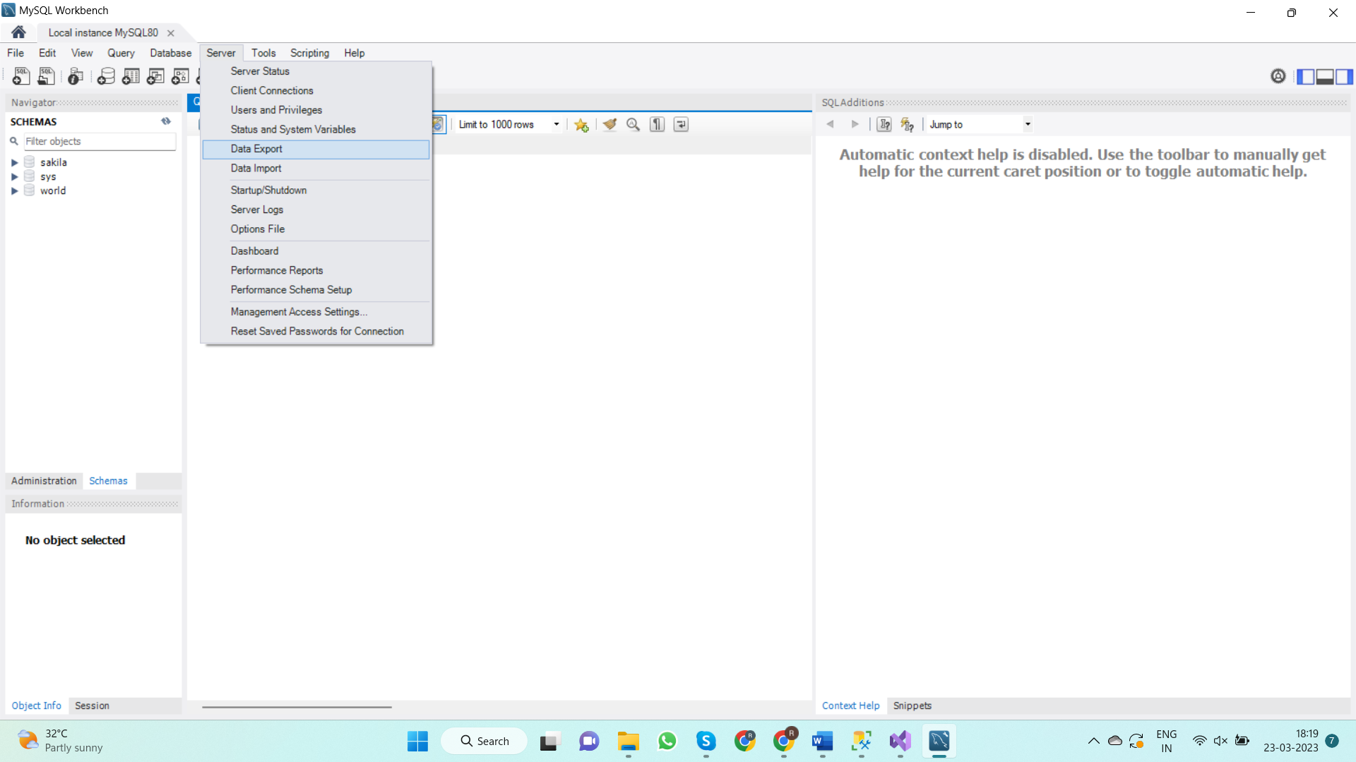

**3.Step 3:**

* Browse the path for **“Import from Dump Project Folder field”**

Path: D:\KSFC\Components\Data\KAR.KSFC.Components.Data.DatabaseContext\SQL Scripts\New Dump\ksfc_oct

* Click on new button next to “**Default Target Schema”**. Enter the schema name and click on **“Start Import”**

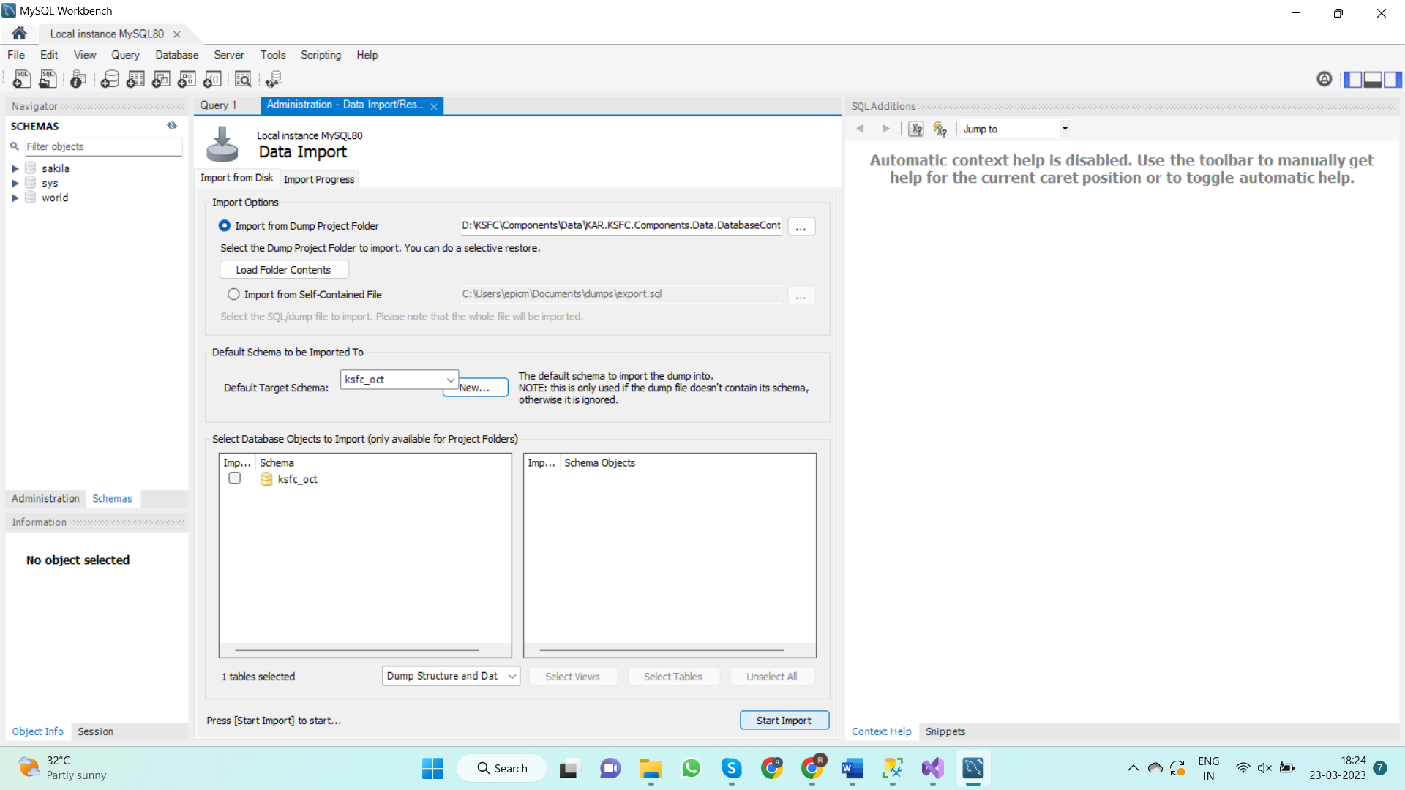

**4.Step 4:**

* Once the import is completed Click on “**refresh icon”** next to **“SCHEMAS”** pane on left side of the Screen to view your imported schema.

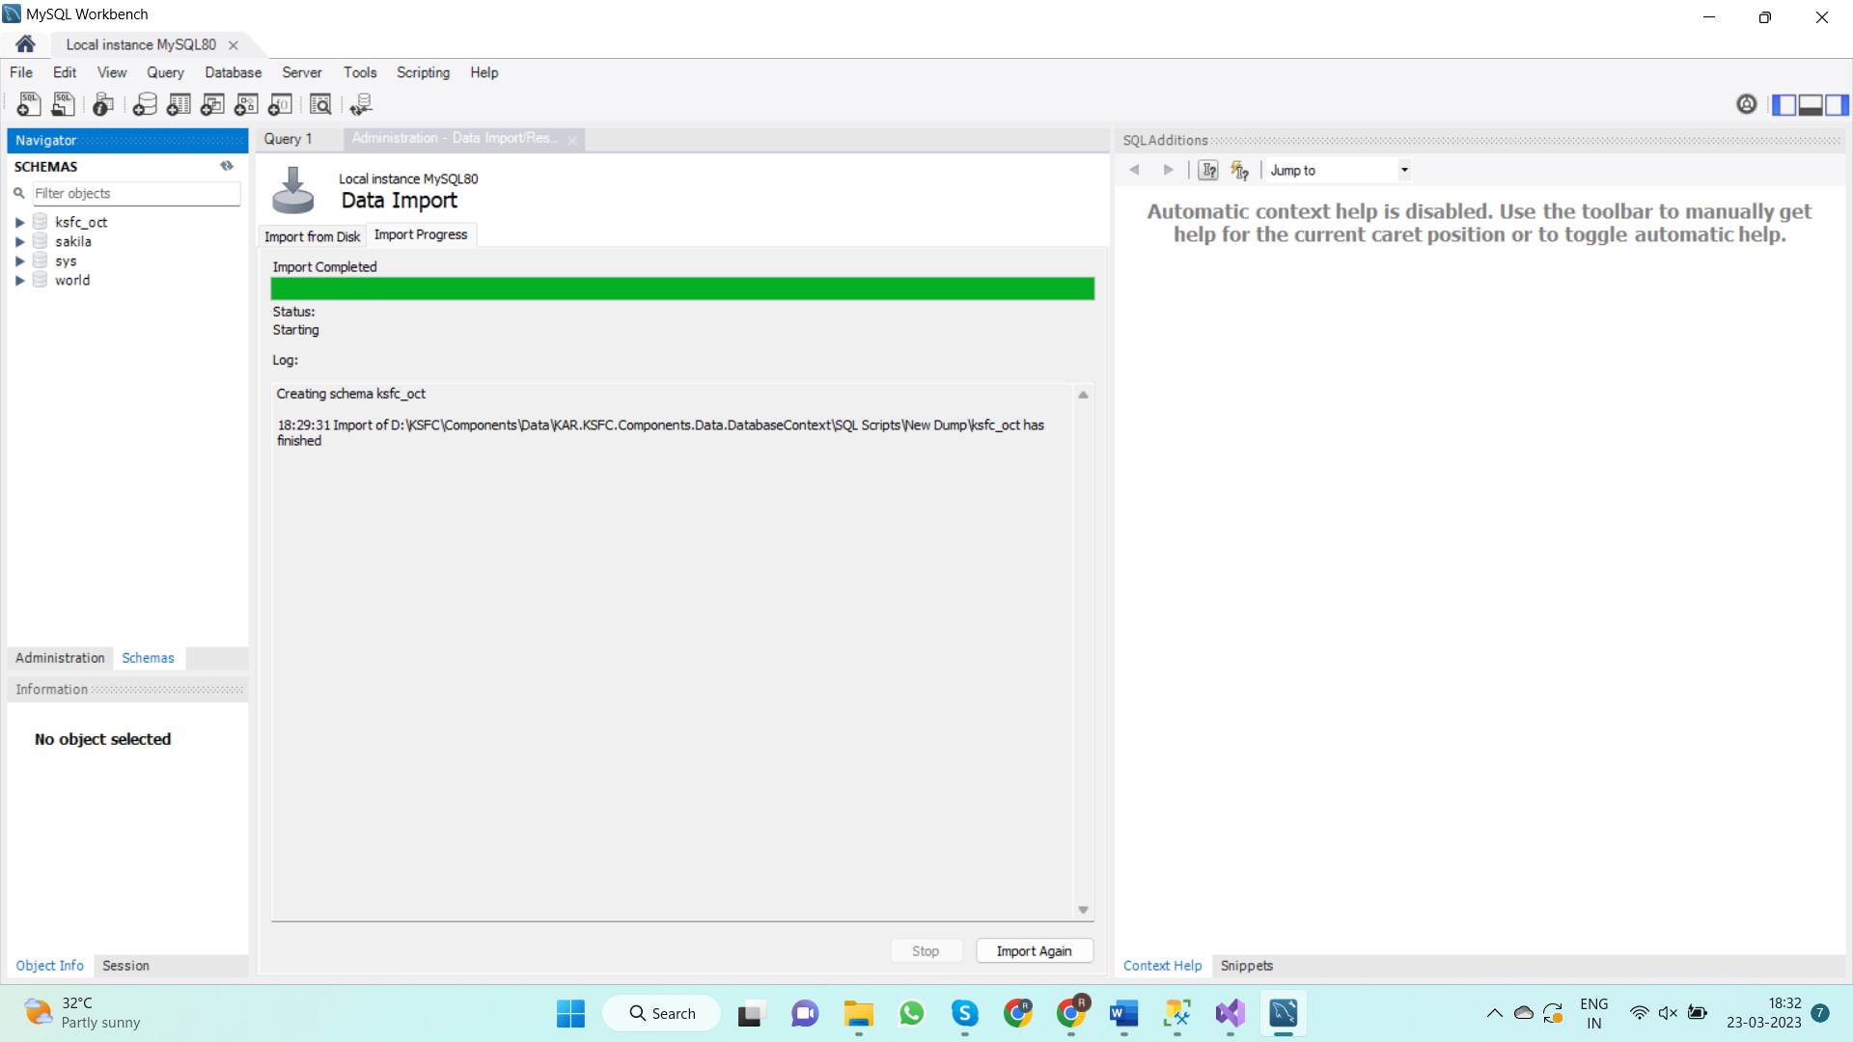

**5.Step 5:**

* Open **“KAR.KSFC.Components.Data.DatabaseContext”** project in visual studio and locate file with the name **“KSFC_oct_NewDump_Collate.sql”**

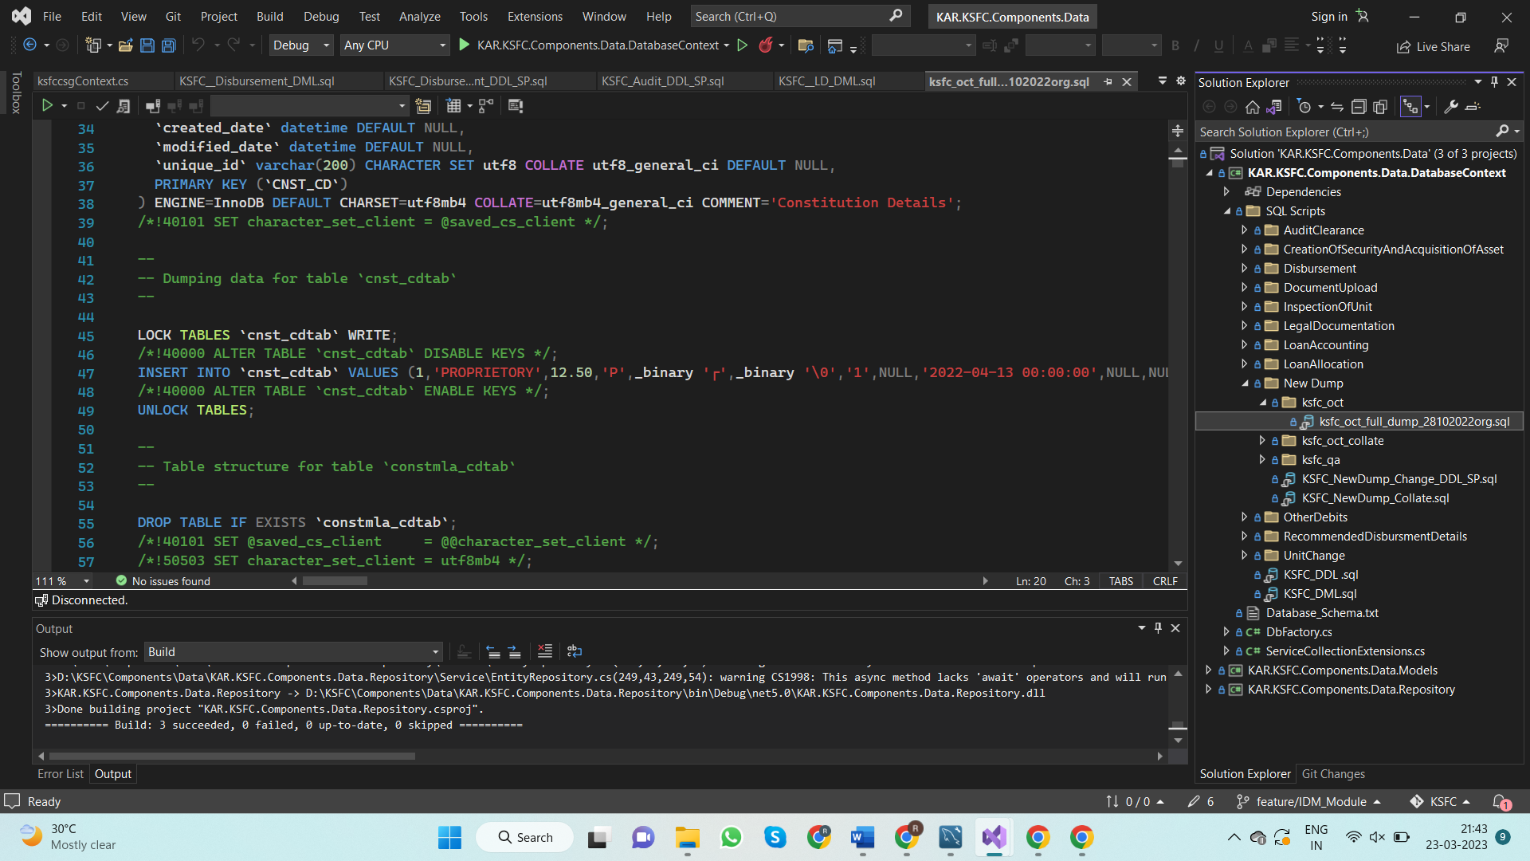

**Path:** D:\KSFC\Components\Data\KAR.KSFC.Components.Data.DatabaseContext\SQL Scripts\NewDump\ksfc_oct_collate\KSFC_oct_NewDump_Collate.sql

* Open the the file and copy the SQL script
* Open MySQL workbench. Click on new Query Editor on top left corner.
* Paste the copied script and execute.

**6.Step 6:**

* Open **“KAR.KSFC.Components.Data.DatabaseContext”** project in visual studio and locate the following 3 files

1.“**KSDFC_LD_DML.sql”**

**2. “KSDFC_LD_DML_SP.sql”**

**3. “KSDFC_LD_DDL.sql”**

**Path:** D:\KSFC\Components\Data\KAR.KSFC.Components.Data.DatabaseContext\SQL Scripts\LegalDocumentation

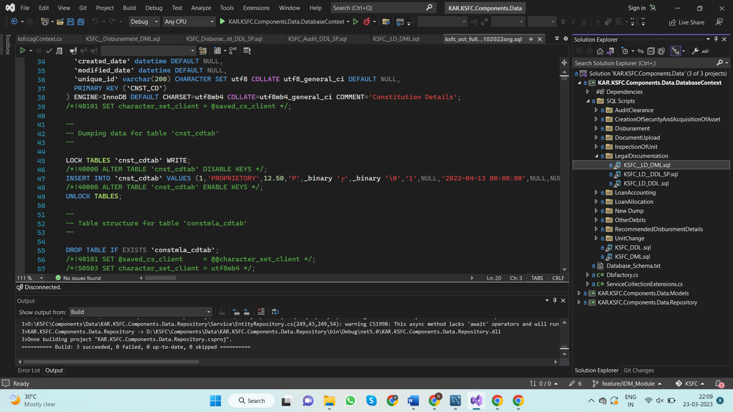

* Copy the SQL scripts from above three files and execute them independently in the following order

1.First, execute the script from the file **“KSDFC_LD_DML_SP.sql”**

2.Then**,** execute the script from the file **“KSDFC_LD_DDL.sql”**

3.Finally**,** execute the script from the file “**KSDFC_LD_DML.sql”**

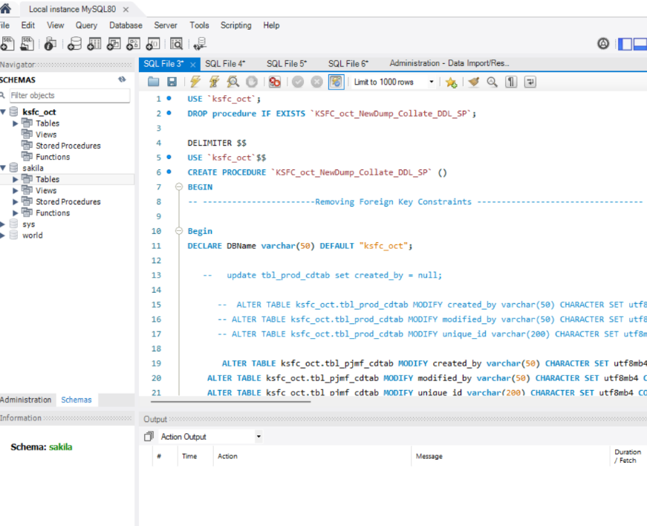

**7.Step 7:**

* Open **“KAR.KSFC.Components.Data.DatabaseContext”** project in visual studio and locate the following 2 files

1**.“KSFC__Disbursement_DML.sql”**

**2. “KSFC_Disbursement_DDL_SP.sql”**

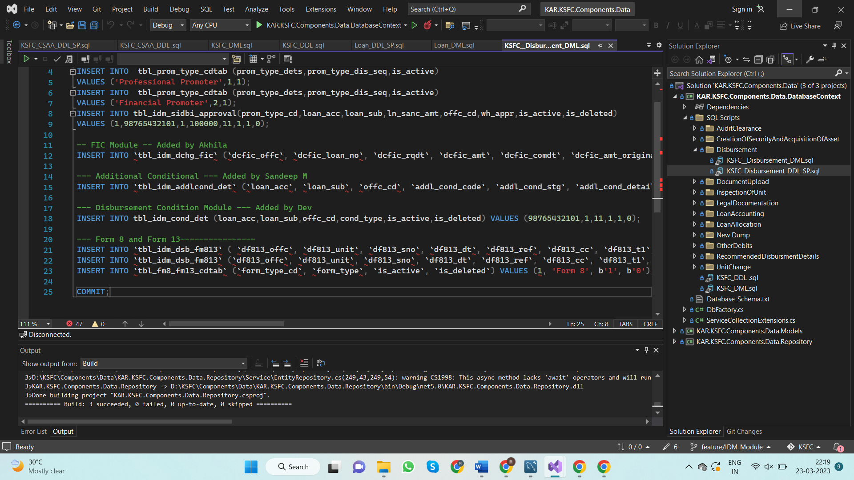

* Copy the SQL scripts from above two files and execute them independently in the following order

1.First, execute the script from the file **“KSFC_Disbursement_DDL_SP.sql”**

2.Then**,** execute the script from the file **“KSFC__Disbursement_DML.sql”**

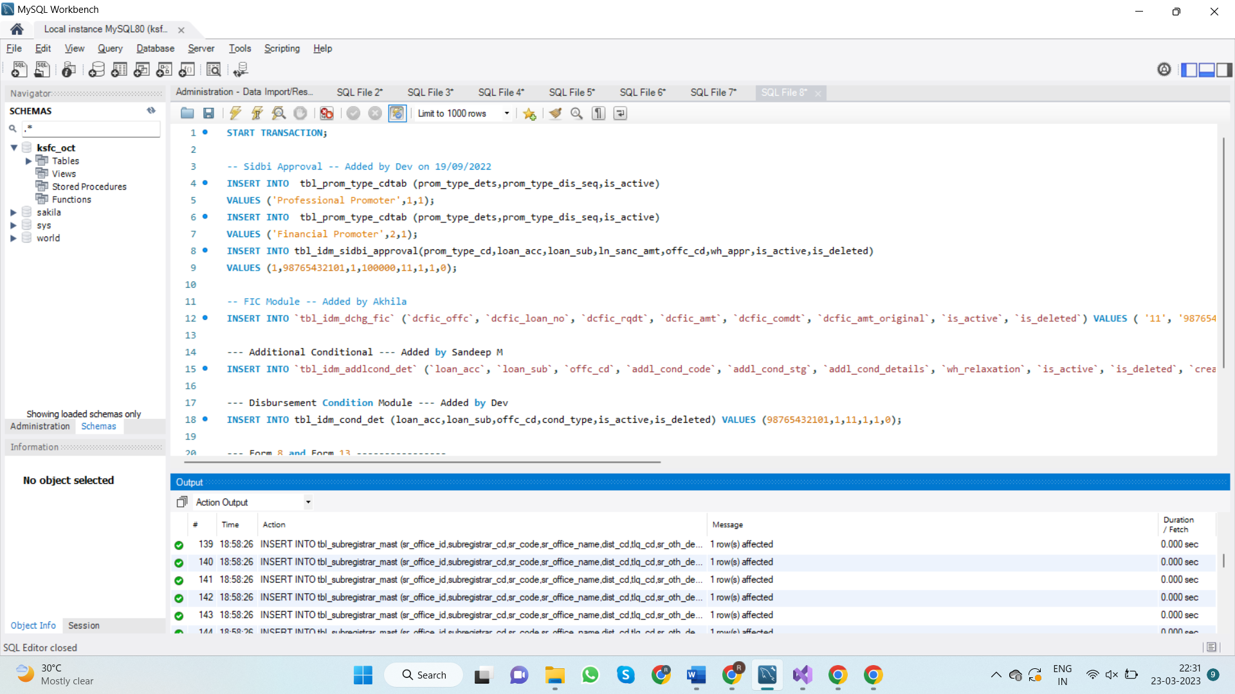

**Steps to run the Project**

**1.Step 1:**

* Open **“KAR.KSFC.API” project**
* Open **“appsettings.Development.json”** file and change user and password that you entered during MySQL installation process

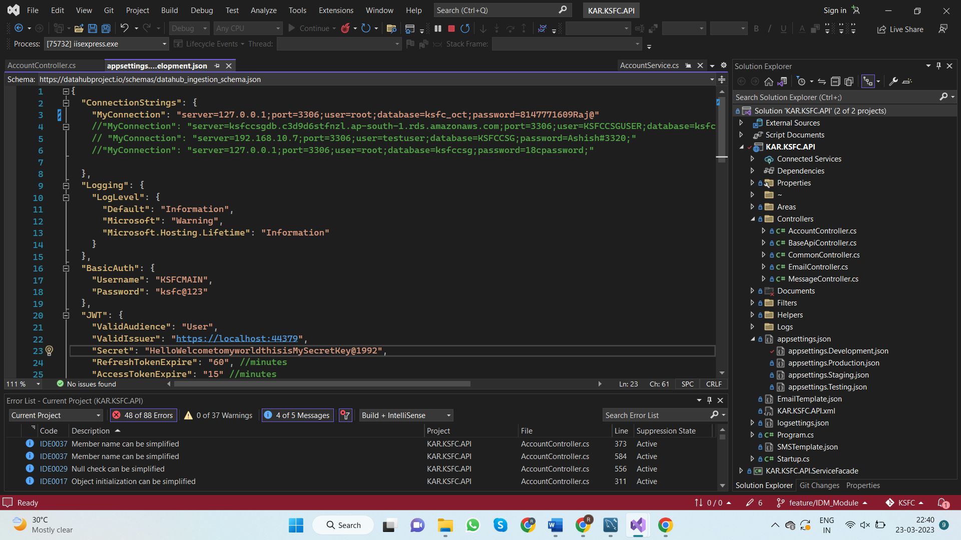

**2.Step 2:**

* Open **“KAR.KSFC.Components.Data” project**
* Open “**ksfccsgContext.cs”** file and change user and password that you entered during MySQL installation process

**Path: D:\KSFC\Components\Data\KAR.KSFC.Components.Data.Models\DbModels\ksfccsgContext.cs**

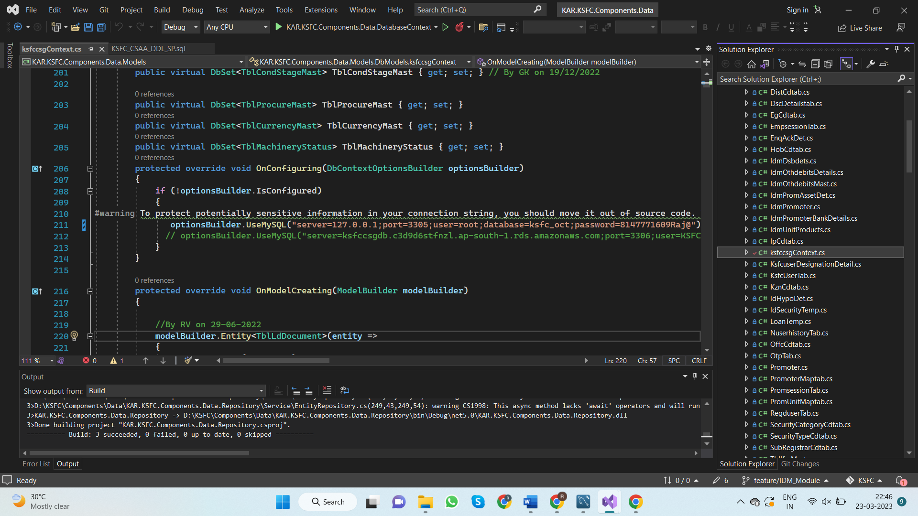

**3.Step 3:**

* Open **“KAR.KSFC.API.sln”** project in visual studio
* Go to build in the menu bar and then select clean project, Once the project is cleaned and then select Build project from same menu.

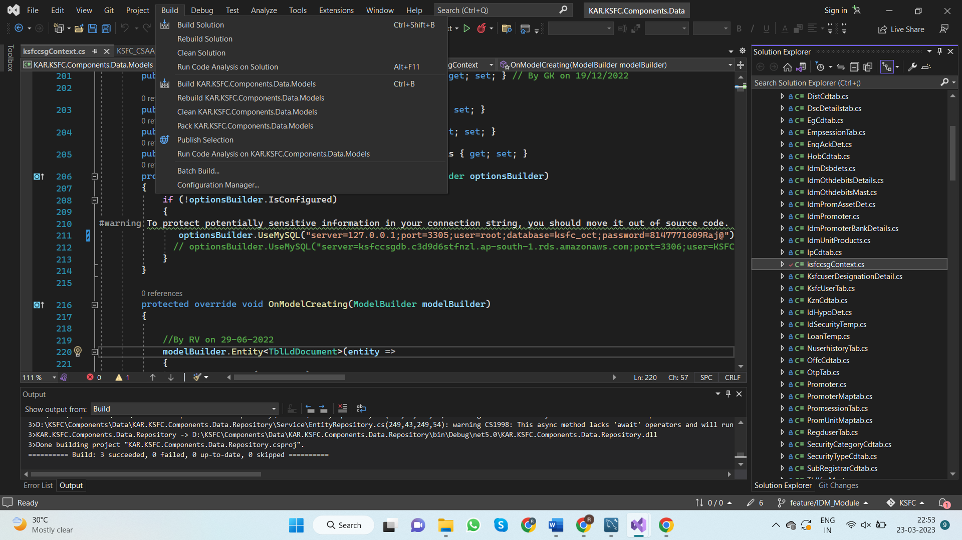

**4.Step 4:**

* Open **“KAR.KSFC.Components.Common.sln”** project in visual studio
* Go to build in the menu bar and then select clean project, Once the project is cleaned and then select Build project from same menu.

**5.Step 5:**

* Open **“KAR.KSFC.Components.Data.sln”** project in visual studio
* Go to build in the menu bar and then select clean project, Once the project is cleaned and then select Build project from same menu.

**6.Step 6:**

* Open **“KAR.KSFC.UI.sln”** project in visual studio
* Go to build in the menu bar and then select clean project, Once the project is cleaned and then select Build project from same menu.

**7.Step 7:**

* Once the above steps are completed first run **“KAR.KSFC.API.sln”** project

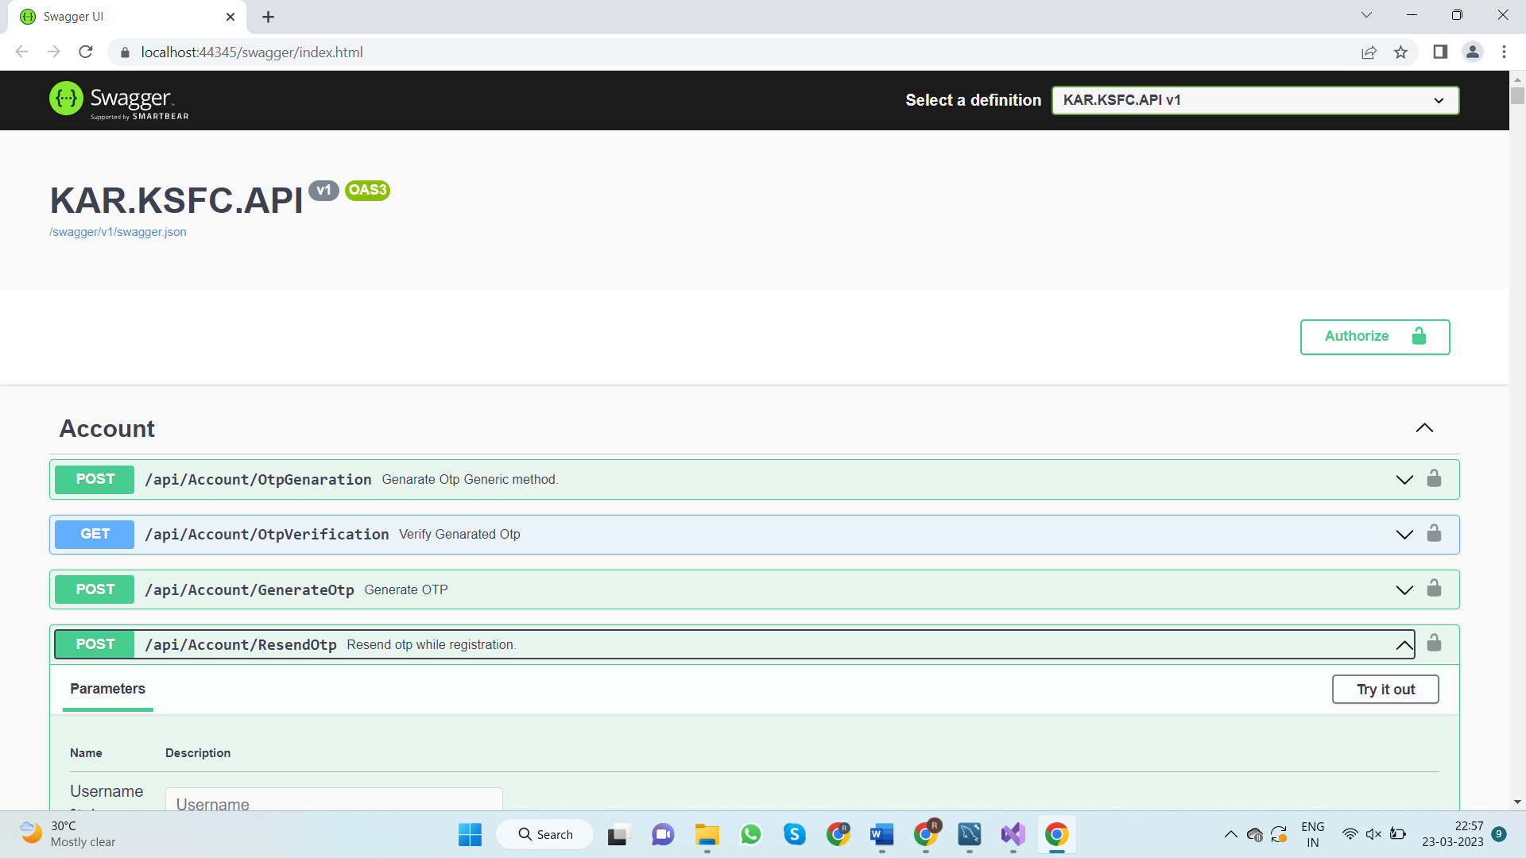

* Now, run the **“KAR.KSFC.UI.sln” project**



* Click on Admin login and enter 00000001 for EmployeeId and Click on Login

